I used Gemini for the mind map exercise. The pre-written prompts did not get Gemini to immediately create a graphic. The initial result was a bulleted list of features, and eventually strategic outcomes and value. I had to request graphics in separate prompts. V1 is ineffective and V3 is preposterous.

V1 Atomic Table
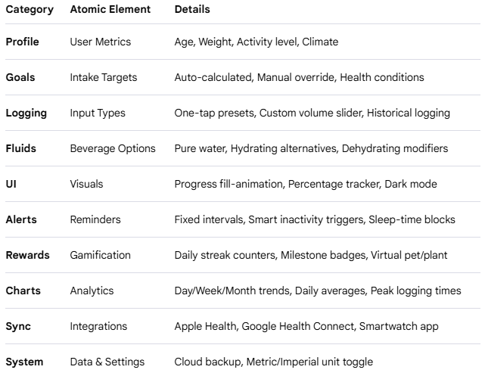

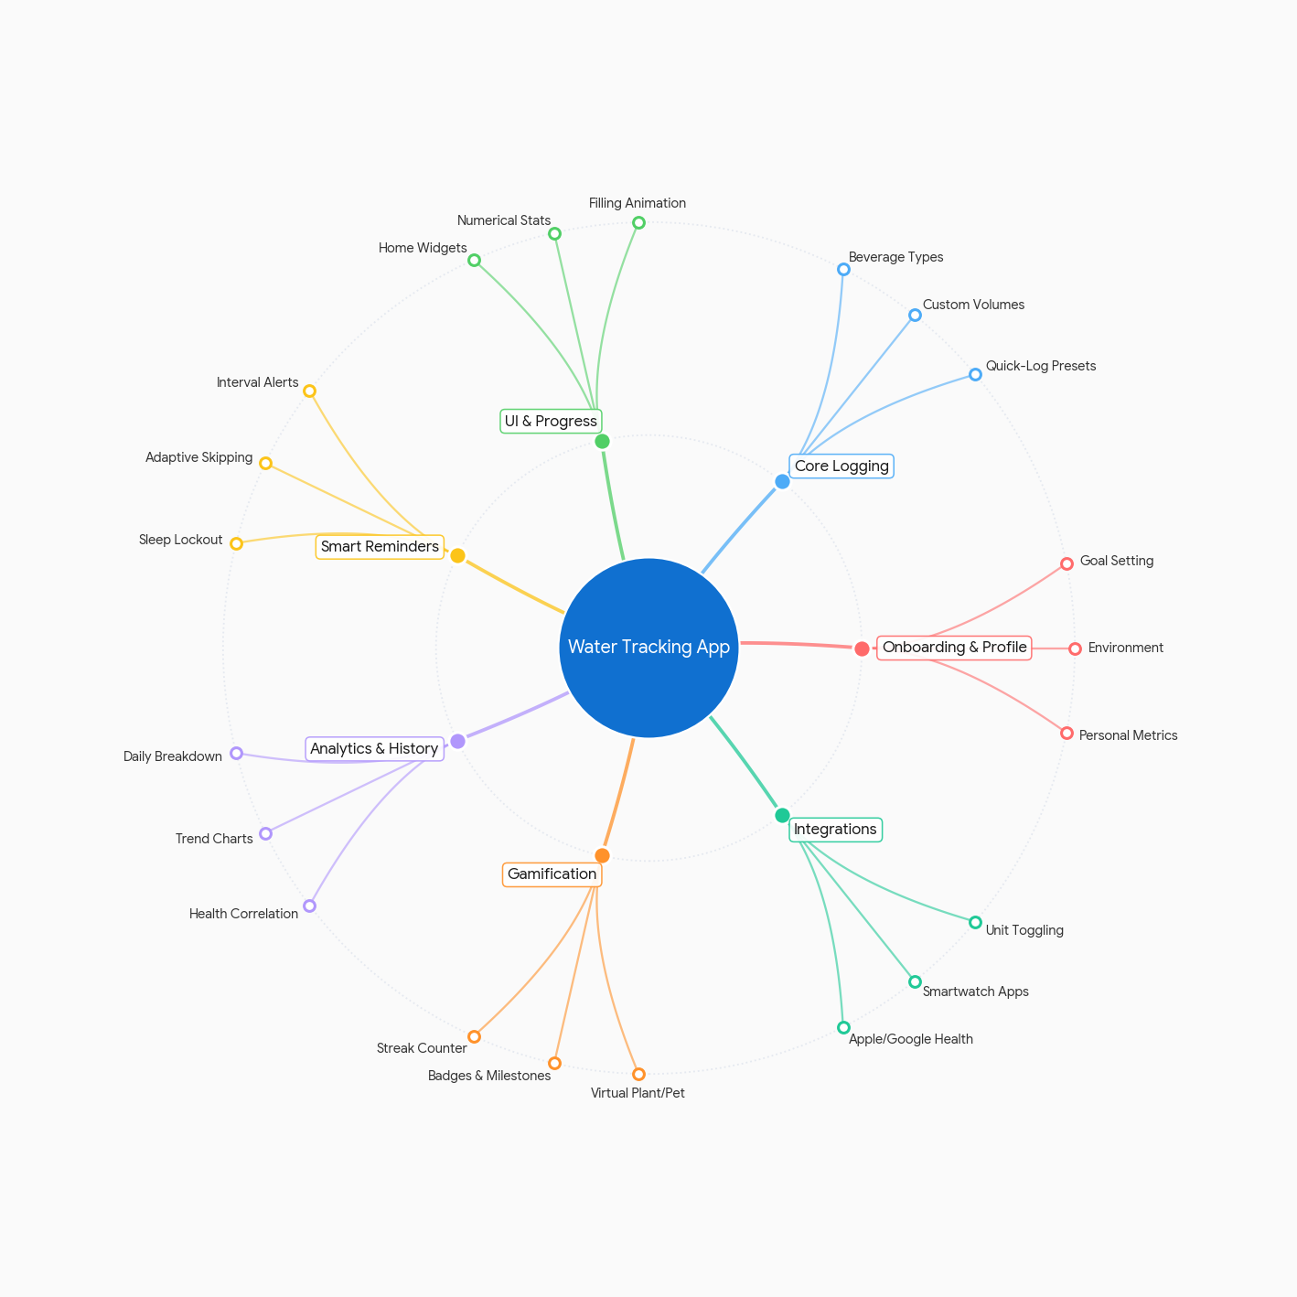
V1 Visual Interpretation

V3 Atomic Table
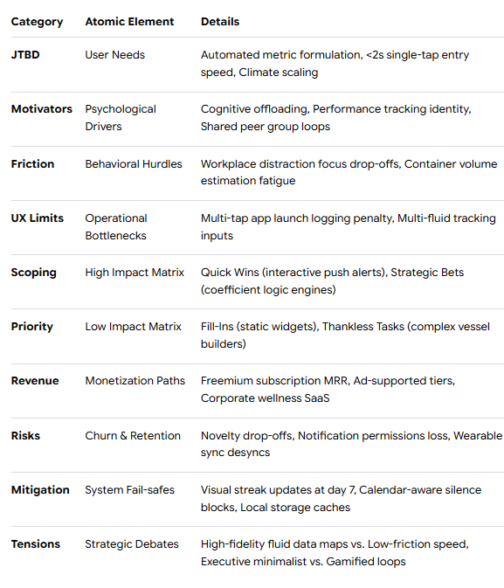

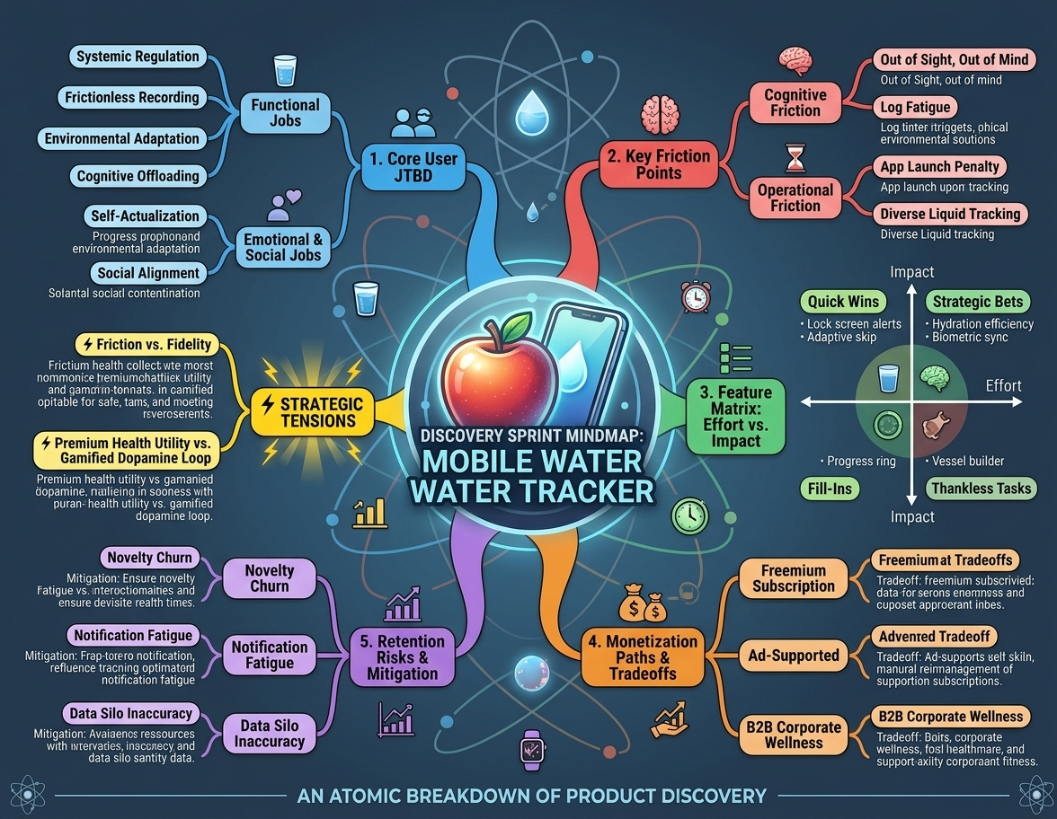
V3 Interpretive Art

